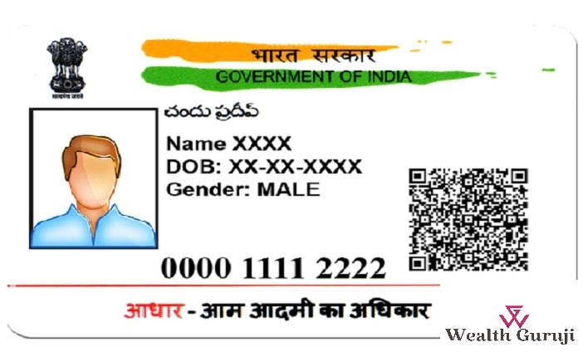

NAME:- SUNIDHI CHAUDHARY

DOB:- 12/01/2008

GENDER:- FEMALE

**0000 1111 2222**

1111123



